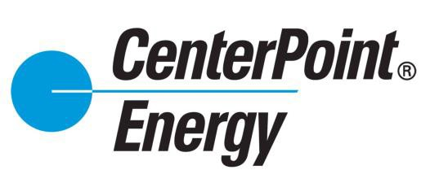
How to Apply for a Volunteer Grant

You will have to log at least 40 volunteer hours toward a non-profit organization before you will see the link to apply for your volunteer grant.

 | Access CNP Cares and click the  ‘LOG HOURS’ link on the top menu. | 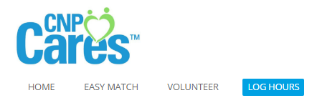
2. | Scroll to the bottom of the page to the ‘Apply for Volunteer Grant’ section.  Click the ‘Apply for a Volunteer Grant link’  Note: The link will only be visible once you have logged the 40 hours towards one organization. Please remember that you may only receive one volunteer grant per year. | 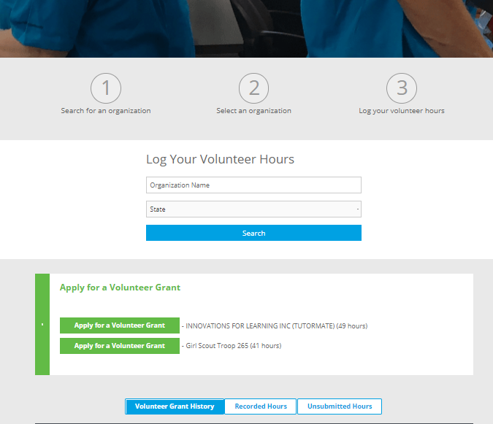
3. | Complete the details of the grant application for the local organization and click ‘Save and Proceed’. | 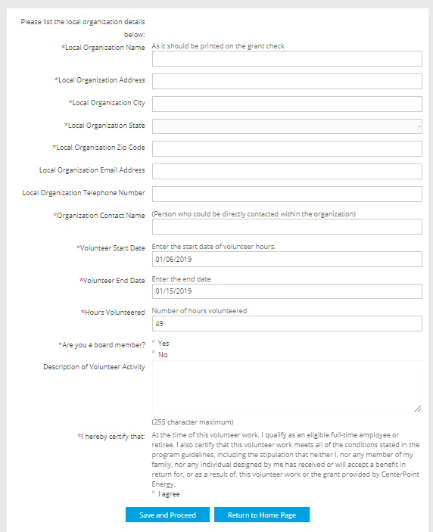
4. | Review the information on the grant application and click ‘Submit” | 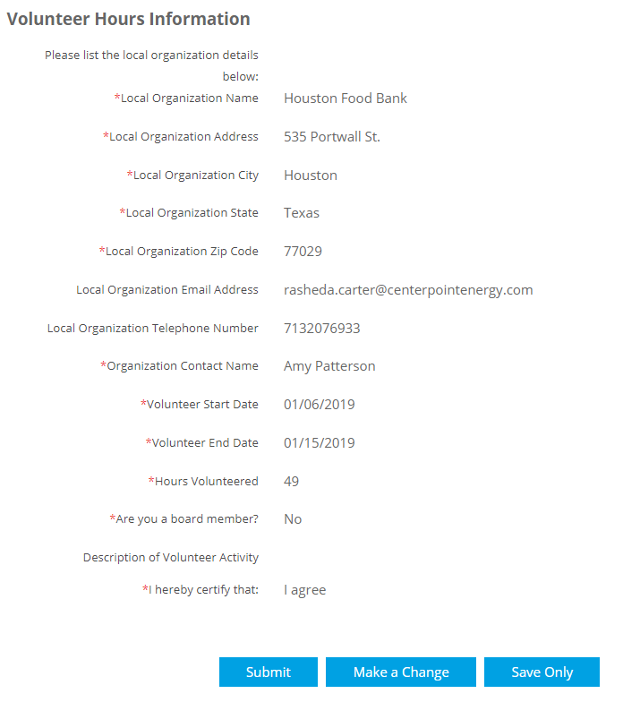
5. | You will receive a confirmation of your successfully submitted grant application.  Grant checks will be processed and disbursed to the employee within 60 days of the quarterly submission deadline. | 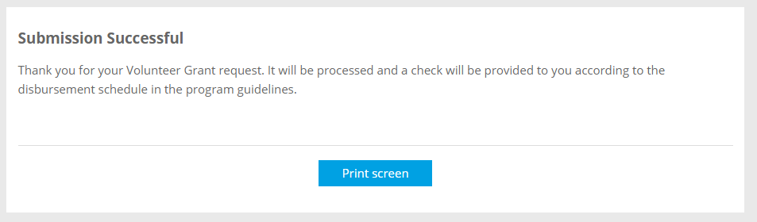  Quarterly Deadlines  Q1 March 31 Q3 September 30  Q2 June 30 Q4 December 31
Contact: Mary Lynn Kallina at MaryLynn.Kallina@CenterPointEnergy.com or 713-207-7596

